Energy in Chemical Reactions
Cornell notes Turner style
Instructions
- Cut out the notes on the right hand side, and paste them into the right hand side of your notebook page.
- Include the vertical black line or redraw this line – giving yourself a large left hand margin
- Read the notes several times
- Ask yourself three questions:
- Can I recognise all the content (information) in the notes?
- In the notes is there a process or procedure I need to know?
- Do I understand the idea/meaning/argument outlined in the notes. That is: do I “get it”?
- Do the following
- Within the notes themselves, underline all the content you should learn or memorise.
- In the left margin label each section of the notes as either a definition, example, explanation, process, or evidence (and you could make up your own categories)
- With each label in step b, write a key word or phrase which tells us what the label is referring to. An example would be…

(note – the example is
not for these notes
- The key words are highlighted)

- At the end of the notes write a summary underneath the notes. The summary should be short – it is to demonstrate your understanding of the notes, not rehash the content. Often you should try to draw a diagram or mind map.

Definition of chemical reaction
label
Key words
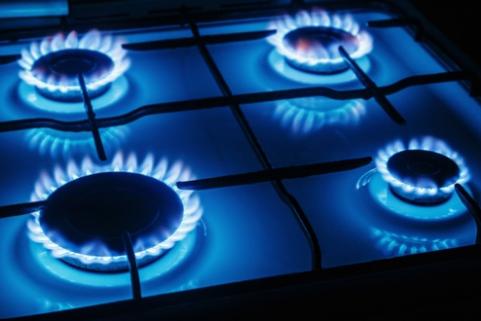
Chemical reactions always involve energy changes. During a chemical reaction energy is transferred either to, or from the surroundings. This cause the temperature to change. For example, when we turn on the gas on our kitchen hob, a chemical reaction, called combustion or burning, takes place. Any Combustion reaction transfers heat to its surroundings, so our food on top of it takes in the heat and cooks. The temperature in our cooking pot rises.
Reactions that transfer energy to their surroundings, like combustion, are called exothermic reactions. Any reaction which gets warmer as it proceeds is an exothermic reaction.
The opposite happens in endothermic reactions. Endothermic reactions take in energy from the surroundings. Therefore, the mixture and the surroundings get colder, as the temperature drops. This temperature drop is sometimes hard to observe. For example - baking a cake is endothermic, but because you heat up the oven so much to bake the cake, you don’t really notice the cooling down effect as the cake bakes.
The energy in chemical reactions can be explain if you understand that both the reactants and the products contain energy. If the reactants contain more energy than the products do, the extra energy will be released (an exothermic reaction) as the reaction proceeds.
The opposite is true when the reactants have less energy than the products do. Such reaction requires us to put the extra energy into the reaction so there is enough energy to make the products. If only a small amount of energy is needed this happens naturally and the surroundings cool down. If a lot of energy is needed (like baking a cake), we have to heat the reaction to a high temperature before it can proceed.
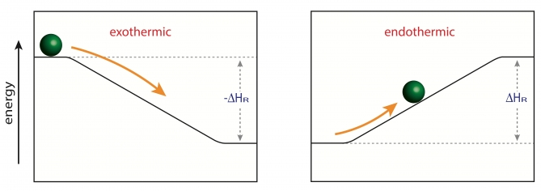
The following diagram shows the energy changes in the reaction mixtures of exothermic and endothermic reactions.

